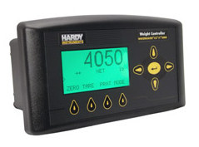
Hardy 4050 Quick Setup Guide
TABLE OF CONTENTS
2.0 INTRODUCTION 1
2.1 Purpose 1
2.2 Quick Guide - Synopsis of Ethernet Set Up 1
3.0 Initial Setup Procedures 2
3.1 Initial Hookup to the Ethernet Port 2
3.2 Configuring the Hardy 4050 to talk to the A-B Processor 3
4.0 Working with Ethernet Communications 5
4.1 Changing the Ethernet Port Address Manually 5
4.2 Configure the PLC Processor 5
5.0 Working with the scale with hard wired communications 6
5.1 Configuring the scale manually 6
5.2 Calibrating the scale using the Ethernet web-page interface 7
5.3 Rate of change configuration 7
6.0 Legacy Systems 8
6.1 Manually Mapping inputs and outputs for Discrete I/O 8
6.2 Configuring the Net Scale Weight Output to Channel 2 8
6.3 Configuring the Rate of Change Output to Channel 4 8
6.4 Configuring the automatic tare switch input to digital input 1 9
6.5 Configuring remote calibration inputs 9
7.0 ADDENDUM A 12
7.1 Found Wiring Issue 12

INTRODUCTION

Purpose
This guide is intended to assist in configuration of the Hardy Model 4050 Scale Transmitter.
It is assumed that the scale transmitter is properly wired and connected to a scale platform.
It is also assumed that the user has access to the CD Manual for this transmitter and is familiar with basic scale concepts.

Quick Guide - Synopsis of Ethernet Set Up
- Get online with Hardy Scale (Default address 192.168.200.123)
- Insure PLC is configured for Hardy Scale (Control Engineering)
- Download Configuration Text File
- Verify text file download (I/P Address should now be 192.168.67.3)
- Operate

Initial Setup Procedures

Initial Hookup to the Ethernet Port
There is an Ethernet port on the rear of the Hardy 4050 weigh transmitter that is used for configuring the Hardy from your computer. This connection has an HTML Web page interface and can be accessed using a Cat 5 and above Ethernet cable (a regular cable or a crossover cable will both work – the port is intelligent enough to switch the connection as required.)
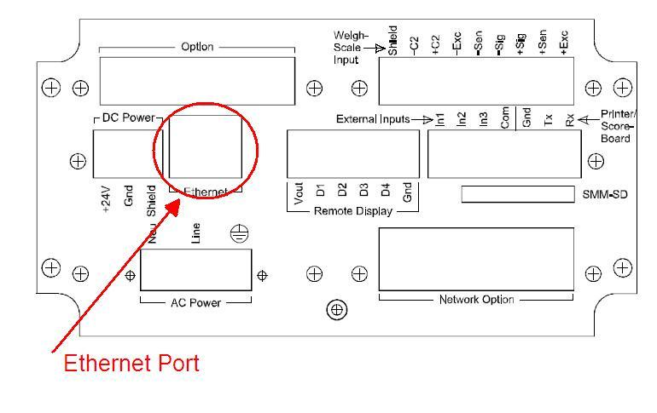 | 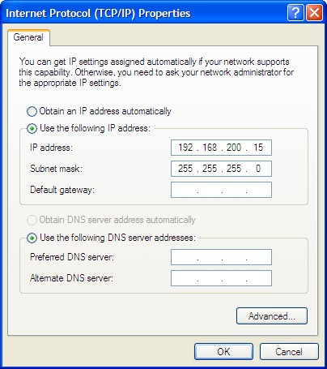 | 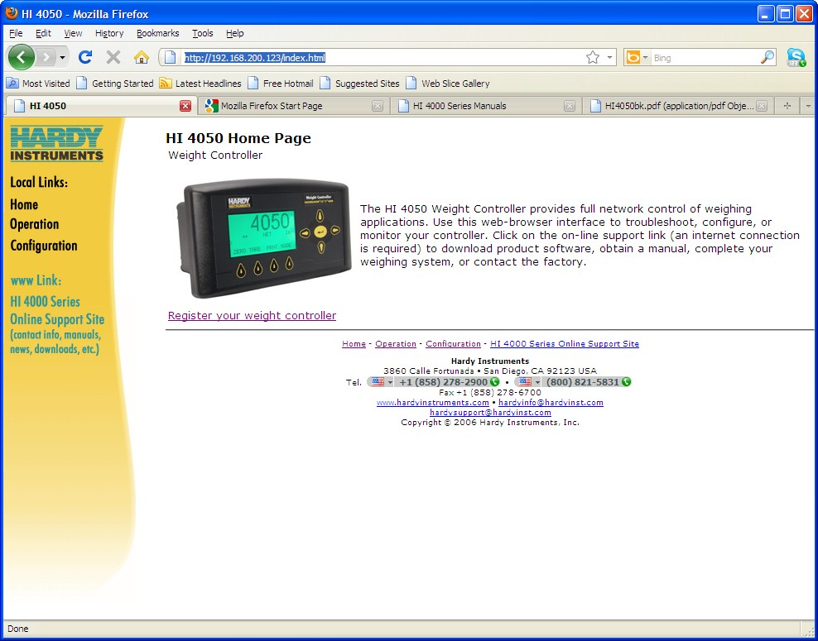
Fig 1 - Ethernet Port Connection, initial Computer I/P Address to talk to Hardy and Hardy Home Page. Note: IP Address is 192.168.200.123 to display this page initially.
- Connect to the Hardy controller using the Ethernet connection port shown in figure 1 (left).
- Configure your computer’s Ethernet address to 192.168.200.15, Subnet Mask 255.255.255.0. The HTML page on the Hardy is at address 192.168.200.123. (Figure 1 Center)
- Open your web browser and type in the address (No HTML characters required) as: 192.168.200.123. The display shown in figure 1 (right) should come up. If it does not, follow the steps below on the actual display (If one is not provided, see control engineering for theirs) to determine the current I/P Address:
Step 1.Press Enter to activate the Configuration menu. Use the down arrow to select Instrument Setup and press Enter.
Step 2.Use the down arrow again to select Ethernet. Finally, select IP to display the IP screen.
Step 3.If the display is not showing the correct IP value, press the CLR button to erase the current value and enter the address 192.168.200.123. The DCHP address should also be the same.

Note: The HI-4050 can be configured to use any fixed IP address you desire. Fixed IP addresses must be carefully selected to avoid accidentally configuring two devices to the same address with unpredictable results. Since ‘guessing’ a value could lead to personal or property damage and/or interrupted network services, your network administrator should provide this address if the scale is to be connected to a customer network. For the purposes of configuration and calibration, however, a direct connection to your laptop computer is assumed.

Configuring the Hardy 4050 to talk to the A-B Processor
Next, the Hardy needs to be configured properly. In order to do that, you will need to access the parameters of the unit, and download a set of parameters that has all the mapping functions properly configured.
- Go to the Hardy internet home page by opening your internet browser to the configured Hardy Ethernet address.
- Obtain the current configuration of the Hardy controller:
  - Click on the Local Link: OPERATION on the left hand side of the screen.
  - Click on Diagnostics
  - Click on the Parameters text in underlined purple on the screen.
  - You will see a text file. Swipe over this text file and save it to text file.

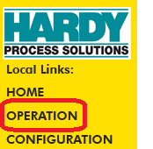  Click on OPERATION | 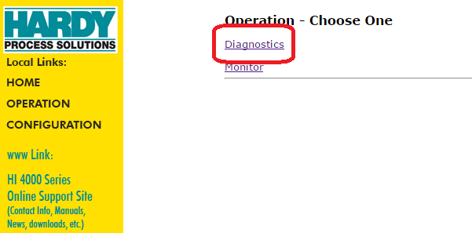  Click on Diagnostics | 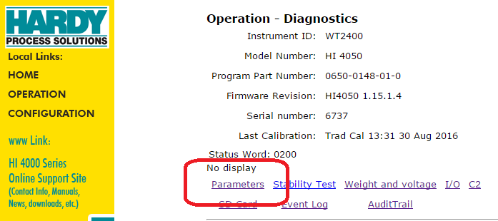  Click on Parameters | 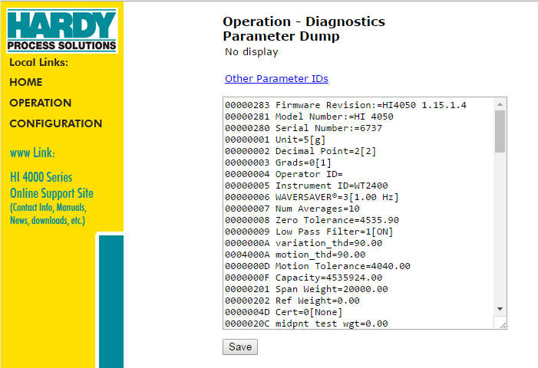
Figure 2 - Viewing and saving the Parameter list

Note:
Some parameters (Such as Firmware Revision and serial number) will not be overwritten, as they are part of the overall hardcoded scale.

Note:
After downloading the text file shown in figure 3 below, the Hardy internet address will automatically change to 192.168.67.3, which is Freund-Vector’s standard default I/P address for the Hardy scale in MOST systems. You will need to reconfigure your computer to an address compatible with 192.168.67.XXX.

After downloading this configuration file, connect to the Hardy scale using the Web Page browser address 192.168.67.3.

Important:
After downloading the text file shown in figure 3 below, all normal configuration of the Hardy scale should have been done for you, and the scale can be calibrated, tared and zero balanced using the PLC communications and interface with most of Freund-Vector’s control systems.

Verify Scale Operation with the control system after this file in figure 3 is downloaded.

Important:
The “Span” range of this download is set to 30 Kg in the parameter file. If the system is using a different span, adjust this parameter after the download is complete, or prior to downloading the text file to the Hardy weigh controller.
Copy the contents of this text file to download to the Hardy 4050 Scale controller.
This text box has the ASCII text necessary for the file.
00000283 Firmware Revision:=HI4050 1.15.1.7
00000281 Model Number:=HI 4050
00000280 Serial Number:=2427
00000001 Unit=5[g]
00000002 Decimal Point=1[1]
00000003 Grads=3[10]
00000004 Operator ID=
00000005 Instrument ID=WT2400
00000006 WAVERSAVER®=0[OFF]
00000007 Num Averages=150
00000008 Zero Tolerance=5000.0
00000009 Low Pass Filter=1[ON]
0000000A variation_thd=90.0
0004000A motion_thd=90.0
0000000D Motion Tolerance=10.0
0000000F Capacity=30000.0
00000201 Span Weight=15000.0
00000202 Ref Weight=0.0
0000004D Cert=0[None]
0000020C midpnt test wgt=0.0
0001020C uncorrected mid wgt=0.0
00010060 ROC Time Units:=1 [min]
00020060 ROC Time Base:=10
00000092 Tare Weight=-0.1
00000010 Mode=0[Gross]
00000011 Type=0[Loss in Weight]
00000012 Target=0.0
00000013 Preact=0.0
00000014 Deadband=0.0
00010010 Mode=0[Gross]
00010011 Type=0[Loss in Weight]
00010012 Target=0.0
00010013 Preact=0.0
00010014 Deadband=0.0
00020010 Mode=0[Gross]
00020011 Type=0[Loss in Weight]
00020012 Target=0.0
00020013 Preact=0.0
00020014 Deadband=0.0
00030010 Mode=0[Gross]
00030011 Type=0[Loss in Weight]
00030012 Target=0.0
00030013 Preact=0.0
00030014 Deadband=0.0
0000001A AutoZero=0[OFF]
0000000E AutoZero Tolerance=0.00
0000002A Baud Rate:=5[19200]
0001002A Data bits:=1[8]
0002002A Parity:=0[NONE]
0003002A Print Mode=0[GROSS]
000002F2 scratchpad=516.000000
000102F2 scratchpad=1.000000
000202F2 scratchpad=0.000000
000302F2 scratchpad=1.000000
000402F2 scratchpad=0.000000`
000502F2 scratchpad=0.000000
000602F2 scratchpad=888.000000
000702F2 scratchpad=0.000000
00000037 EIP Bytes In=20
00010037 EIP Bytes Out=20
00000208 Calibration Date=Trad Cal 12:39 15 Feb 2018
00000203 Cal Low Counts=8415451
00000204 Cal High Counts=9359345
00000205 Cal Span Factor=4.805716872215E-02
00000206 Zero Counts=8415469
00000209 Cal Zero Counts=8415451
0000020A ITECH=0 0 0 0 0 0 0
0000020B Gravity Correction=1.000000
0000020D A/D rate=1 [110]
0000021A Jbox1Sensors=3 [4]
0001021A Jbox2Sensors=3 [4]
0000001D zone=3[PST(GMT-8h)]
000002F0 MAP:=EIO0=+HFI0*HFO1, EIO2=+HFI1*HFO1, HO2.0=+EI0.0, HO2.1=+EI0.1, HO2.2=+EI0.2, HO2.3=+EI0.3, EO6.0=+~EO6.0, HFO0=+HSI1, EIO4=+HFI6*HFO3
00000300 Display Mode=0
00000301 Display Line=0
0000002D High Security Code=0
0001002D Medium Security Code=0
0000002E FPSecurity=0[NONE]
0000002F Calibration Security=0[NONE]
00000030 Web Page Security=0[NONE]
00030060 ROC Key=1489570
00020037 EIP key=1453495
00000023 HardyPort=1024
00000025 IP=192.168.067.003
00000026 Mask=255.255.255.000
00000027 Gate=192.168.067.003
00000028 DNS=192.168.067.003
00000029 DHCP:=192.168.067.003
01000037 EIP Product Code=1
Figure 3 – Parameter list Text File – copy this file to controller

Note: if communications is lost after downloading, change parameters above to: EIP Bytes In=256 and EIP Bytes Out=256.

Working with Ethernet Communications

Changing the Ethernet Port Address Manually
Note: The Hardy must be configured for the IP Address used in the Control System. This is usually 192.168.67.3. However, you should check the software specification of the individual machine.

In order to change the I/P address manually, you must first download an executable from the Hardy Website. The link is below:

http://www.hardysolutions.com/products/weighing-instruments/weight-controllers/product/482/hi-4050-single-scale-weight-controller

Note: This executable may also be found in the Training Validate Directory:
G:\VALIDATE\Training\Quick Setup Guides\Hardy 4050 Weigh Controller
Install this executable on to your computer. Make sure your I/P address is initially 192.168.200.15, then open up the executable (Note: answer any security queries your computer will confront you with to download and open the executable):
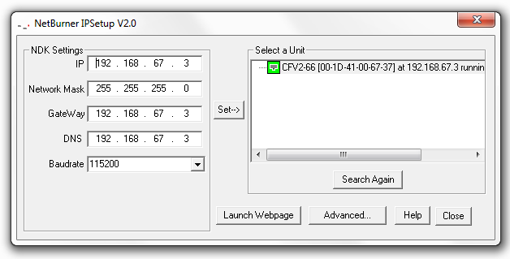
Figure 4: Hardy I/P Setup, configuring to 192.168.67.3. Press the “Set→” key after entering the desired I/P address. Make sure the Network Mask, GateWay and DSN addresses also match the figure above.

Configure the PLC Processor
Start by configuring the Ethernet address as described in the initial sections. Your control engineer should assist you in this effort to configure the PLC Processor, if it has not already been configured.

Allen-Bradley Scale Communications:
The scale must be configured on the Allen-Bradley system by the control engineer:
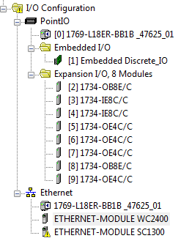 | 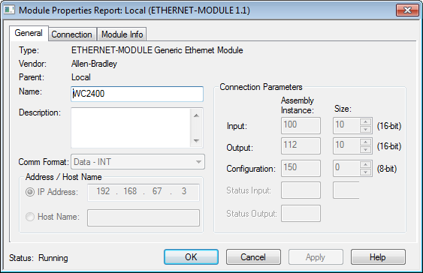
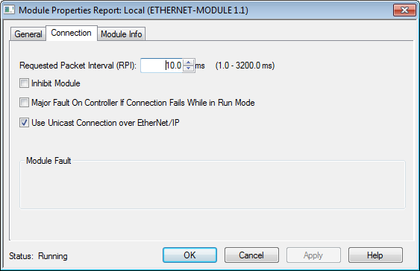 | 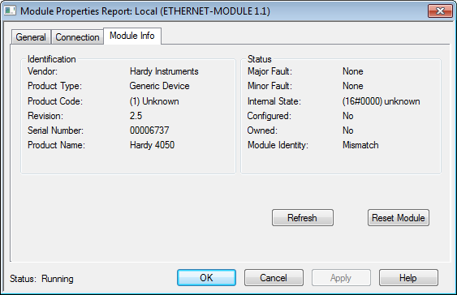
Figure 5: A-B Ethernet Module Configuration

Working with the scale with hard wired communications
The procedures above should get you communicating with the scale in record time.
However, if you are working on a “legacy” system with hard-wired interfaces (4-20 mA loss in weight, digital in and out), this procedure can quickly configure a weigh scale to replace an existing unit.

Configuring the scale manually
The scale setup is rather straightforward using the Ethernet interface.
Select “Configuration” on the main menu then select “Instrument Setup.
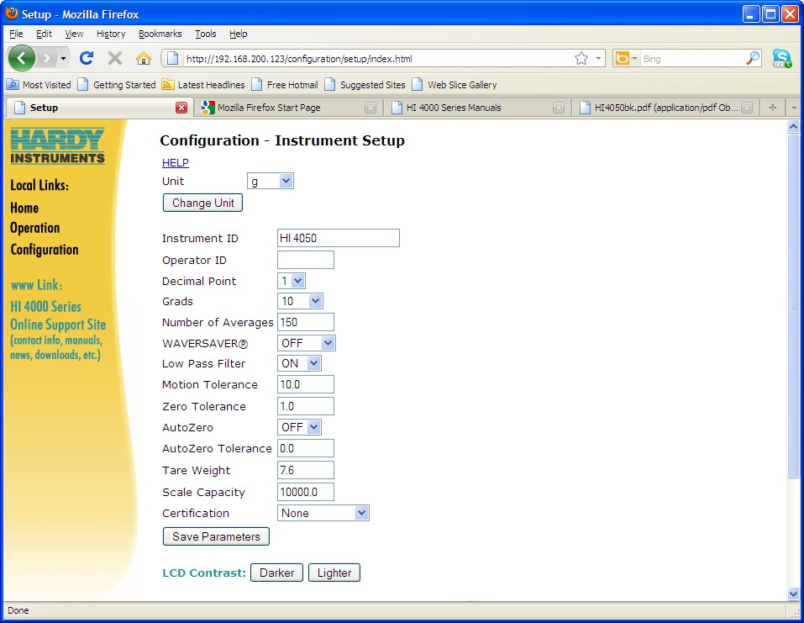
Figure 6: Instrument Setup – Note: Screen taken from a 0.0 – 10000.0 gram scale unit.
Important Parameters:
- Units (Must select one – note that all other configuration [Analog outputs for flowrate and weight transmitted out] will be based on this unit.)
- Instrument ID: Standard is HI 4050. If using an Ethernet comms to the PLC, this is usually WT2400.
- Decimal Point:
Note: The rate will need one more decimal point than this display. For example, if you want a rate to have a resolution of +/- 1 gram/min, you must put a decimal place of 1 in this field to give you that resolution when rate is configured. For this example, we used a scale range of 0.0 – 10000.0 grams, with a loss-in-weight range of 0 – 300 grams/min. You need the decimal place on the total weight display to get good rate resolution.
- Scale Capacity:
The scale capacity of the system. The scale capacity can be found on the bottom of the scale (typically). Use the same units as the weigh scale is configured for.

Calibrating the scale using the Ethernet web-page interface
The Hardy weigh transmitter can be calibrated fairly quickly using the web interface. You may want to use this method for initial calibrations of the weigh controller.
- From the home page, click on “Configuration”. Then Click on “Calibration”.
Note: We will almost always use Method 2, Zero and Span calibration.
- Empty the scale. Enter a reference weight of 0.0
- Click on the “Do Cal Low” button. The web page should show “Cal Completed OK” with a “back” text underlined.
- Click on the “back” text. This will take you back to the” Configuration – Calibration” screen.
- Load a calibrated known weight on the scale. Important!!! Enter the span weight in the units that the scale is configured for and is present on the scale. Click on the “Do Cal High” button.
- Your Scale net weight should be calibrated. Test as required.

Rate of change configuration
The scale can be configured to display and/or re-transmit rate of change. (Freund-Vector typically uses this to display and control solution flowrate.)
To configure the rate of change option:
- From the Main Menu, select “Configuration”.
- From the Configuration menu, select “Options”.
- From the Options menu, select “ROC”. (ROC = Rate of Change)
- Enter a Time Measure unit of “Min” from the pull down menu.
- Enter a time base of 5 to 45 seconds. (Note: The larger the number, the more sluggish the solution flowrate response will be, but also it will be smoother. For typical spray operations, 10 to 15 seconds is acceptable.)

Legacy Systems

Manually Mapping inputs and outputs for Discrete I/O
This scale transmitter can come with four analog outputs configurable to various things, and 3 digital inputs from the PLC to tell the scale to do various things. Typically, Vector either uses the Ethernet communications to directly communicate from the scale to the PLC, or uses the Analog Output card option to communicate the scale’s weight and rate to the PLC.
If the Ethernet method is used, service adjustment is not required (A control engineer’s responsibility will be to configure the right communications parameters and insure proper operation with the PLC).
This section describes how to map the I/O so that the following configuration is made. The Hardy weigh controller will have to be ordered with this I/O card set already installed:
Slot 0:
Channel 1 – Voltage Output – spare
Channel 2 = Current Output – Net Scale Weight
Channel 3= Voltage Output – Spare
Channel 4 = Current Output – Solution Flowrate (Rate of Change)
Digital Inputs:
Channel 1 = Tare
Channel 2 = Spare
Channel 3 = Spare

Configuring the Net Scale Weight Output to Channel 2
- From the Main Menu, select “Configuration”.
- From the Configuration menu, select “Mapping”.
- Select the top “Control” pull-down menu.
- Select the “Analog card output 2 (HFO29)” selection. This will direct the selected reading to this analog output.
- Click on the “Select” button that appears on the screen next to your selection. This will enter the value “HF029=” into the expression field on the bottom of the screen.
- Next, select the “Process Data” field down arrow and select “Net Weight (HFI2)”.
- You should have an equation that looks like “HFO29=HFI2”.
- Click on the “Map” pushbutton. This will “map” the net weight to analog output 2.

Configuring the Rate of Change Output to Channel 4
- From the Main Menu, select “Configuration”.
- From the Configuration menu, select “Mapping”.
- Select the top “Control” pull-down menu.
- Select the “Analog card output 4 (HFO31)” selection. This will direct the selected reading to this analog output.
- Click on the “Select” button that appears on the screen next to your selection. This will enter the value “HFO31” into the expression field on the bottom of the screen.
- Click on the “ ~ “ (not) operator. This adds an “ ~ “ sign to the equation, which means “take the negative of the value – in this case, rate of change.
- Next, select the “Process Data” field down arrow and select “Rate of Change (HFI6)”.
- You should have an equation that looks like “HFO31=~HFI6”.
- Click on the “Map” pushbutton. This will “map” the rate of change, corrected to read a positive value, to analog output 4.

Configuring the automatic tare switch input to digital input 1
- From the Main Menu, select “Configuration”.
- From the Configuration menu, select “Mapping”.
- Select the “Process Data” pull-down menu.
- Select “Tare(HO2.0)”. This will select the “Tare” function.
- Click on the “Select” button that appears on the screen next to your selection. This will enter the value “H02.0=” into the expression field on the bottom of the screen.
- Next, select the “Control” field down arrow and select “User Switch 1 (HI0.4)”.
- You should have an equation that looks like “H02.0=HI0.4”.
- Click on the “Map” pushbutton. This will “map” the digital input 1 to the Tare function.

Configuring remote calibration inputs
In order to do this, you must have dry contacts wired to inputs IN2 and IN3. For this example, we’ve made IN2 the zero calibration point, and IN3 the Span calibration point.
- From the Main Menu, select “Configuration”.
- From the Configuration menu, select “Mapping”.
- Select the Destination “Control” pull-down menu.
- Select “Hard Cal Low”. This will select the “Hard Cal Low or Zero” function.
- Click on the “Select” button that appears on the screen next to your selection. This will enter the value “HO2.2=” into the expression field on the bottom of the screen.
- Next, select the “Control” field down arrow and select “User Switch 2 (HI0.5)”.
- You should have an equation that looks like “HO2.2=HI0.5”.
- Click on the “Map” pushbutton. This will “map” the digital input 2 to the Hard Cal Zero function.
- Next, do the same for the “Hard Cal High”. Select “Hard Cal High (HO2.3)” in the “Control” drop box and press the SELECT button to add it to the equation below.
- Select the “Control” pull down menu and select “HI0.6” to add input 3 to the Cal Span function.
- Press the “Select” button next to the Control pull-down menu.
- You should have the equation that looks like “HFO12=HI0.6”. Press the MAP function key.
- You will need to make sure that the Cal Span Weight and Cal Low Weight values are not mapped to anything. To do this:
  - Select Cal Span Weight (HFO12) from the “Instrument Setup:” menu and click on the “Select” button.
  - With just the equation HFO12= in the working field, press “Map”. This will erase any preset mapping of the Cal Span Weight.
  - Likewise, select Cal Low Weight (HFO13) from the “Instrument Setup:” menu and click on the “Select” button to add it to the equation. Press the “Map” function key to erase this.
- Finally, you can check your configuration of the scale by clicking the “here” text underlined in the text at the bottom of the screen “Click here for an expanded map”. This will display a summary of commands that are in the controller at the present time. You should have something that looks similar to Figure 7.
Note: If you have extra commands, such as “HF028(Analog Output 1)=+HFO0 (Float Variable)” in the mapping, do not be concerned as analog outputs 1 and 3 are not used in this configuration. If you are using these outputs, make sure they are mapped properly.

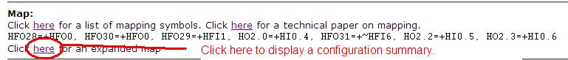
Figure 7: Displaying a mapping summary.

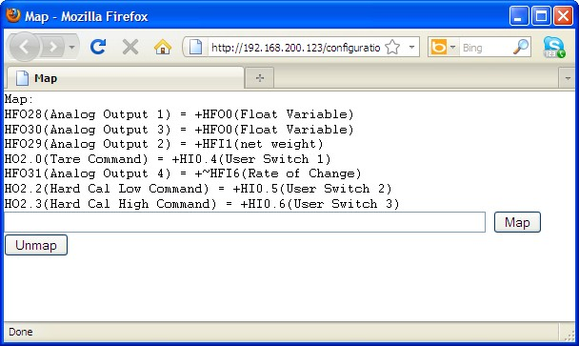
Figure 8: The Expanded Configuration Map Summary Screen.

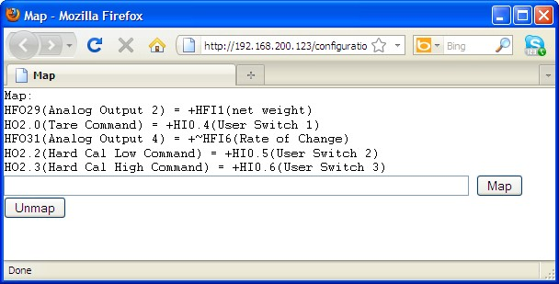
Figure 9: Mapping just what you need to have on the controller. HFO28(Analog Output 1) and HFO30 (Analog Output 3) removed.

Finally, you will need to specify the cal zero and cal span values. To do this, you need to go to the calibration screen.

- From the Home screen, click on “Configuration”.
- Then Click “Calibration”
- You will see two calibration method choices, Method 1 and Method 2. We will be using method 2. You will need to run a calibration at least once with the Ethernet port connected.
- For this example, the cal low weight is nothing on the scale (scale cleaned and dry). Enter a zero amount and click on the “Do Cal Low” button.
- Add your span weight (In our example, 10 kilos or 10000 grams).
- Enter 10000 (or your span weight) and click on the “Do Cal High” button.
- Observe the values after the calibration is done. If the cal high amount comes back with a zero rather than your entered value, you will have to make sure that the Span Cal High (HFO12) value isn’t programmed in the controller. See the procedures above to remove this from the programming.

ADDENDUM A
Check to see if you have 3 or 4 pairs of wires coming from the scale. If only 3, the controller needs 4 pairs to work. Jumper the EX+ to SEN+ and EX- to SEN-. This will make the it work with our machines.

